**Experiment 1.3**

**Student Name: Rahul Kumar UID: 20BCS7081**

**Branch: CSE Section/Group: 716/B**

**Semester: 6th Date of Performance: 27 Feb 2023**

**Subject Name: CC lab**

**AIM:**

Implement the concept of heap Model in lab.

**Objective:**

1. To learn Min heap and Max heap.
2. Data structure is used to implement the heap.

**Requirements:**

Vscode , leetcode , PC or Laptop ,etc.

Question 1:

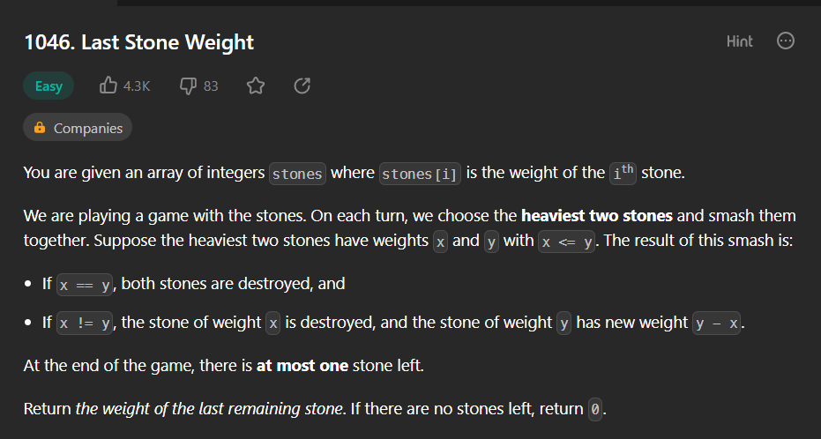

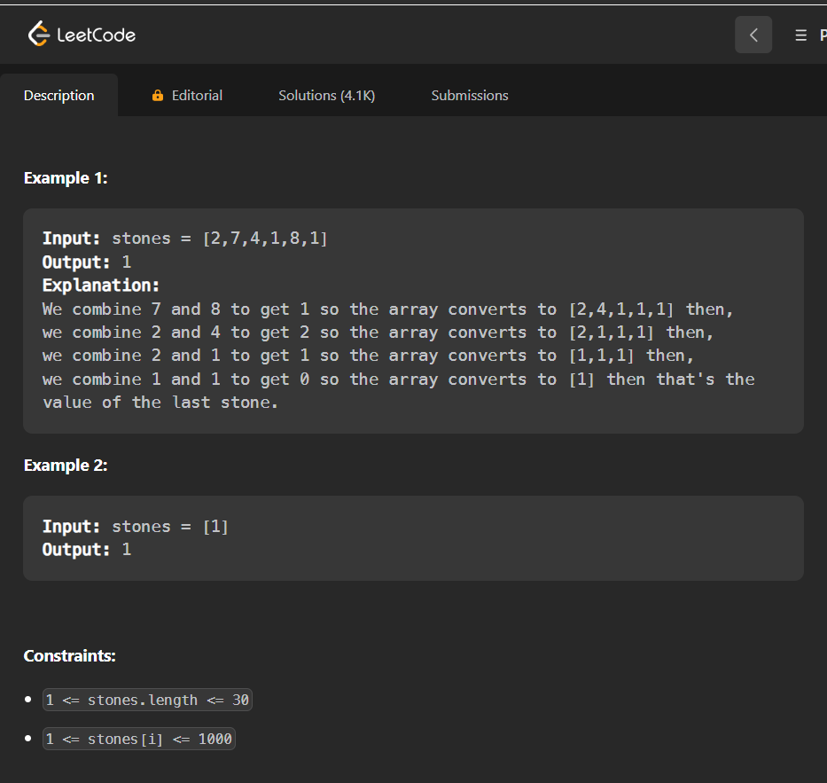

**Answer –**

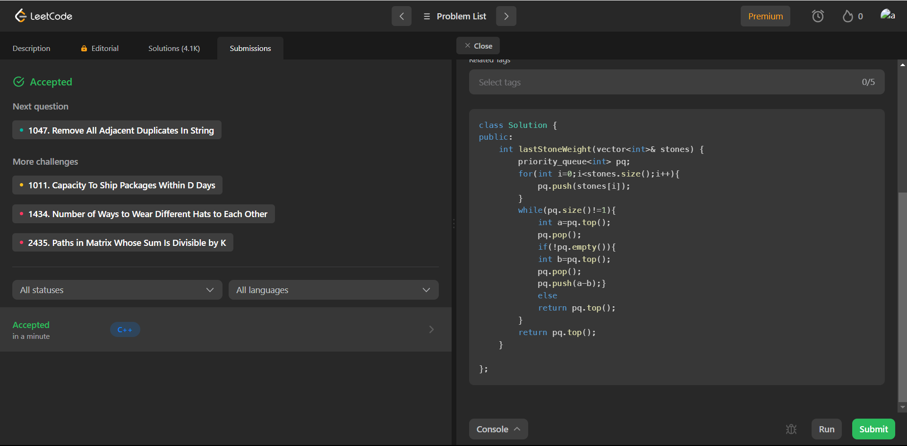

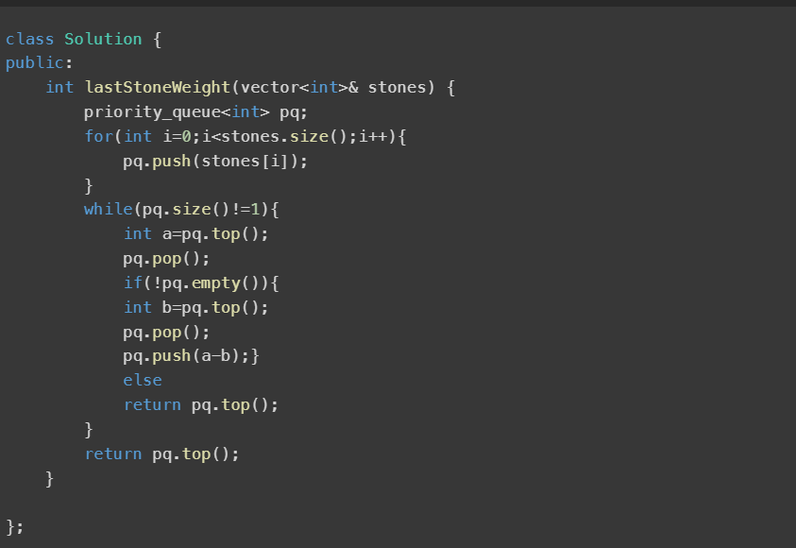

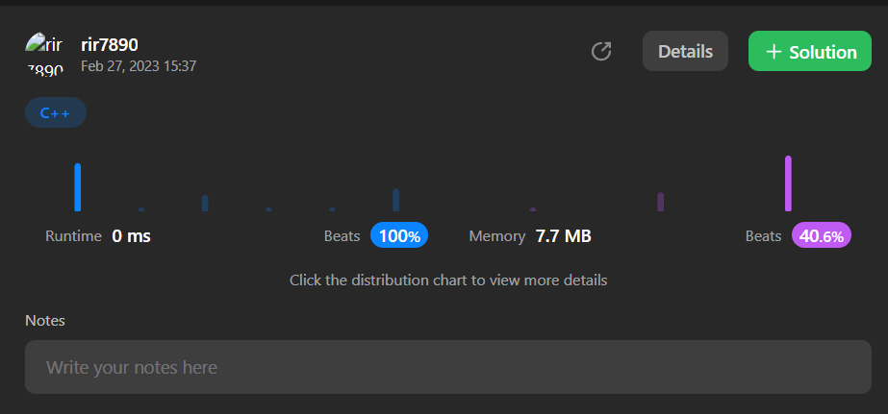

**Question 2:**

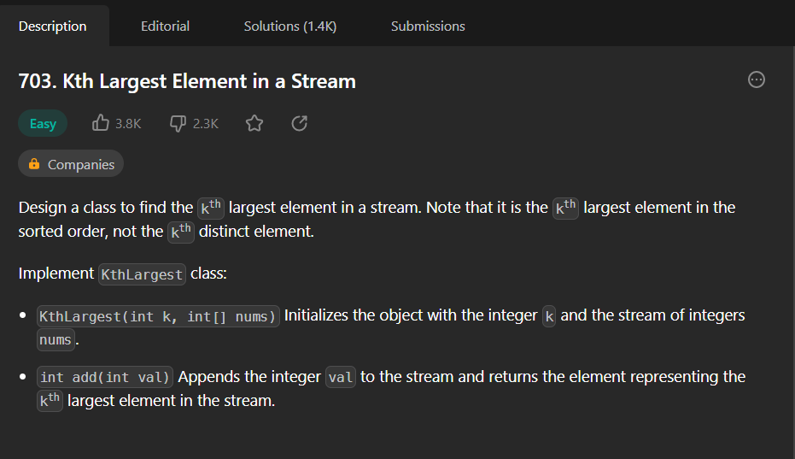

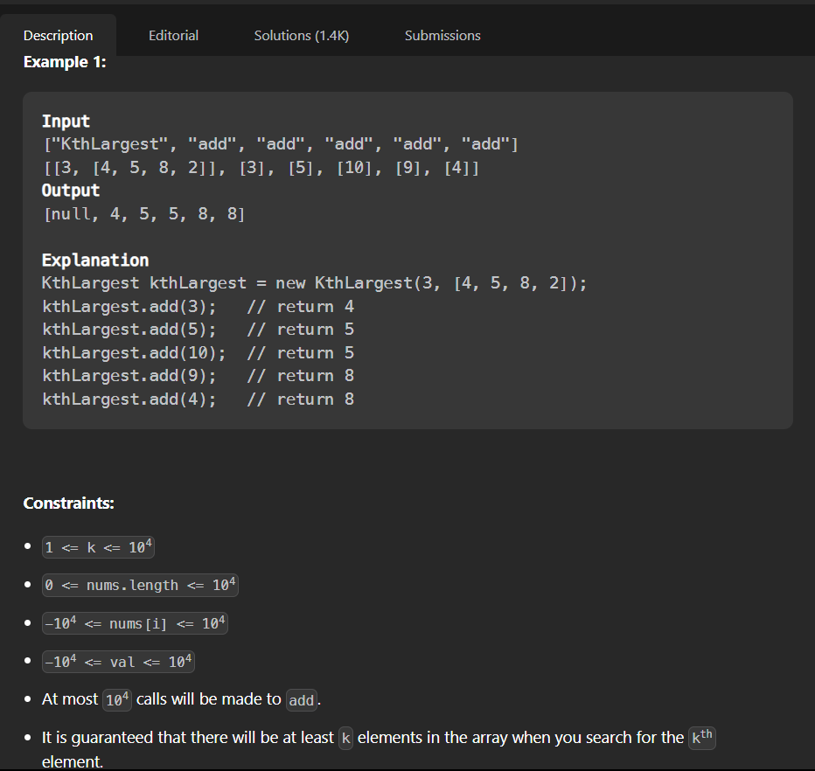

**Answer –**

